“Autoencoder Market Models for Interest Rates” by Alexander Sokol
- Introduction
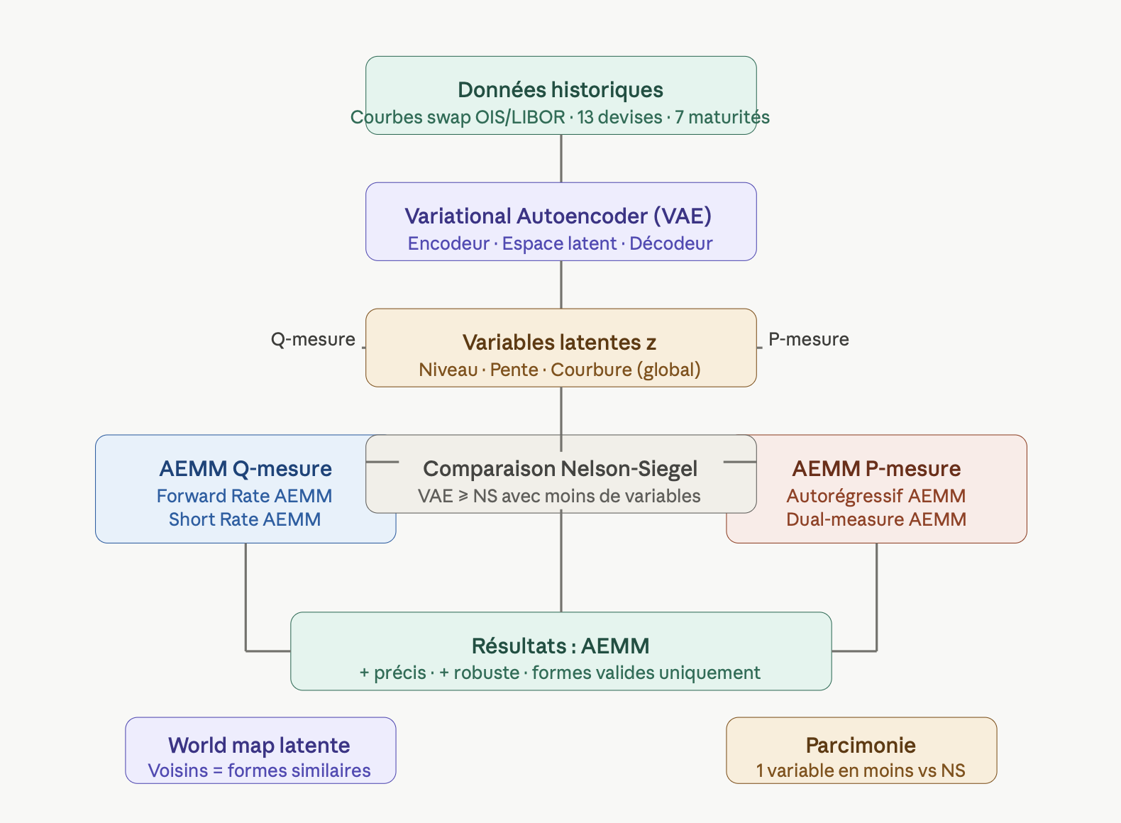
- Objective: The central problem is dimensionality reduction in interest rate models.
A term structure model (which describes how rates evolve across maturities) requires state variables (a small set of numbers that summarize the entire yield curve at a given time).
Too many state variables → the model becomes slow, hard to calibrate, and prone to overfitting.
Too few → the model misses important risks and produces unrealistic curve shapes.

- Key Questions:
  - Is aggressive dimensionality reduction necessary?
  - Can machine learning outperform classical approaches like Nelson-Siegel?
  - Does the VAE approximate the curve better than NS/NSS?
  - Does it generalize better (out-of-sample)?
  - Single-currency vs multi-currency: which performs better?
  - Is the added complexity of VAE justified?

- Core Idea: The approach replaces traditional state variables with the latent variables of a VAE trained on historical yield curves -> Autoencoder Market Models (AEMM).

The key intuition: a VAE trained on thousands of real curves learns to represent only realistic shapes. Impossible or absurd curves have no representation in latent space; they are filtered out during training -> any generated curve automatically resembles a historically observed one.
A helpful analogy: instead of compressing arbitrary images, imagine training a compressor only on human faces. The compressed dimensions become interpretable features like “hair,” “smile,” or “skin tone,” and reconstructed images always look like plausible faces.
- Assumptions:
  - Deterministic volatility: Volatility is fully determined by the yield curve → no need to model separate randomness (no stochastic model) → only compress the curve.
  - Past ≈ future: Historical curve shapes represent future possibilities → works in normal conditions, may fail in new regimes.
  - Latent variables = state variables: VAE latent factors are assumed to capture the true market dynamics → only valid if the model is well-trained and reconstructs accurately.

- Practical Workflow (to refine):
  - Step 1 - Representation: Each yield curve (7 maturities: 2Y, 3Y, 5Y, 10Y, 15Y, 20Y, 30Y) is encoded as a 7-dimensional vector.
  - Step 2 – Encoding: The encoder maps this vector into two vectors of dimension d (typically 2 or 3):
    - Mean μ + Standard deviation σ
    - These define a Gaussian distribution in latent space
  - Step 3 - Sampling (Reparameterization Trick):
    - A latent vector is sampled as: $z=μ+σ⋅ϵ, with ϵ∼N(0,I)$. This allows gradients to flow through stochastic sampling.
  - Step 4 - Decoding: The decoder reconstructs the yield curve from z.
  - Step 5 - Multi-Currency Training: The VAE is trained on data from 13 currencies (optionally using a Conditional VAE). This forces the latent space to capture universal curve structures.
  - Step 6 - Integration into Classical Models: A traditional model (e.g., Hull-White or HJM) replaces its state variables with $z$. The stochastic process evolves in latent space, and the curve is reconstructed via the decoder.

- Why It Works: The argument is geometric and statistical -> real yield curves occupy only a tiny subset of all theoretically possible curves. The VAE learns this low-dimensional manifold.
Latent variables act as coordinates on this manifold ensuring generated curves are always plausible.
An analogy: JPEG compresses any image moderately well, but a model trained only on faces achieves extreme compression by exploiting domain-specific structure. Similarly, the VAE captures correlations across maturities far better than Nelson-Siegel.

- Limitations :
  - Cannot generate truly unseen curve shapes (e.g., entirely new regimes)
  - Strong dependence on training data quality and diversity
  - Performance degrades with fewer currencies
  - No built-in guarantee of arbitrage-free behavior (requires post-processing in Q-measure models). The model can generate yield curves that allow arbitrage opportunities, which should never exist in a correct financial model.

- Autoencoders for the Yield Curve
  - Curve Representation

- Key Questions:
  - What exactly is fed into the model?
  - How do you represent a yield curve as a fixed-length input vector?
  - Which market data points (e.g. maturities, swap rates) are selected?
  - How do you ensure consistency of inputs across time?
  - How does your representation impact model quality?
  - Is the input construction replicable and robust?
  - Does the chosen representation preserve economic interpretability?
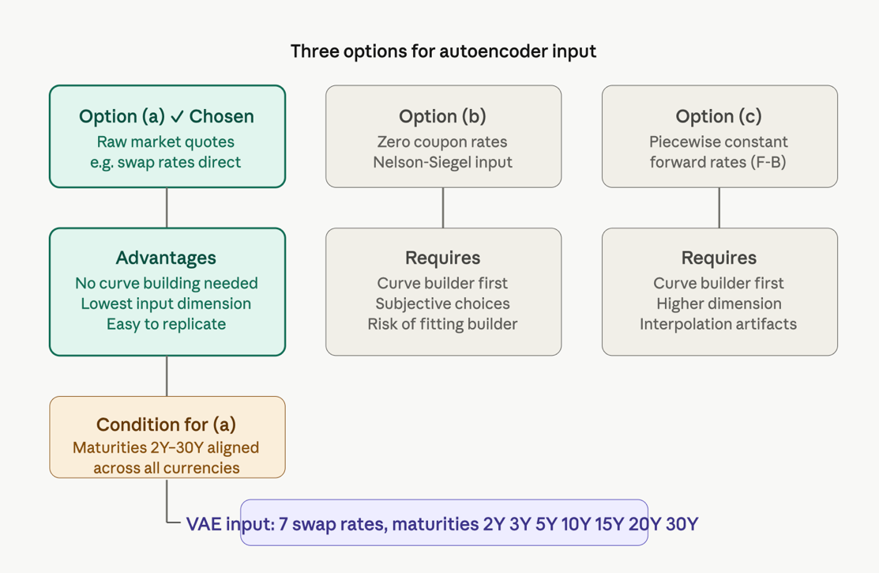

- Assumptions: The most
  - 2Y–30Y & 7 tenors is sufficient: The model assumes that restricting the curve to the 2Y–30Y segment and using only 7 liquid maturities is enough to capture its shape → this simplifies the problem but risks losing information (especially at the short end), which can impact accuracy and completeness.
  - Maturity order is ignored: The VAE receives an unordered vector (no info that 2Y, 3Y, etc.) → it must learn structure purely from data. Why? To avoid relying on artificial smoothness from interpolation and force true pattern discovery. Trade-off: more rigorous test, but potential loss of economic structure.

- Core Idea: We must choose what representation of the curve you feed into the VAE: Either raw market data Or processed outputs from a curve builder:

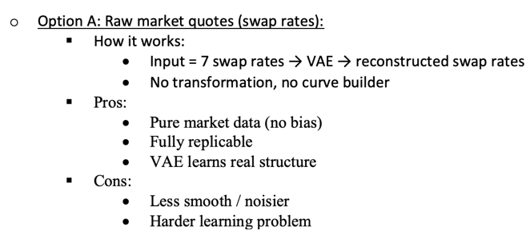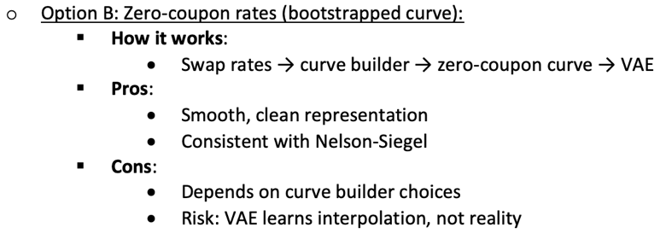

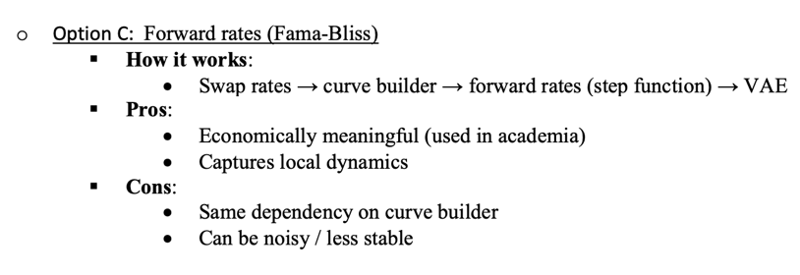

- Why it works – the parsimony argument: Nelson-Siegel uses fixed, hand-crafted factors that don’t adapt to the data, which limits its flexibility. The VAE learns its basis directly from data, capturing real patterns (like segments of the curve moving independently).
Result -> Because its representation is data-adapted, the VAE matches Nelson-Siegel’s accuracy with fewer factors.

  - Classical Nelson-Siegel Basis

- Objective: This section establishes the classical benchmark that the VAE will be measured against. Nelson-Siegel is that benchmark: it is the dominant parametric curve representation used by central banks, practitioners, and academics worldwide.

But Sokol goes further than just presenting the formula. He traces its mathematical origins to reveal a crucial insight: Nelson-Siegel's specific functional form was not the result of an optimization for maximum parsimony. It was an approximation motivated by a desire to reduce the number of free parameters. This historical argument is the paper's main justification for why a VAE can do strictly better.

- Main idea: The Nelson-Siegel basis represents a yield curve using only three numbers:
  - $β_{1}:shifts the entire curve up or down$
  - $β_{2}:$ rotates it (controlling slope)
  - $β_{3}:$ adds a hump or trough in the middle
  - plus a fixed decay parameter $λ$: controls where that hump peaks

These three numbers compress 7 observed rates (or a continuous curve) into a compact description. The claim is that this is a good compression because the three factors have clear economic meaning.

Sokol’s key argument is that despite this parsimony, large regions of the 3D Nelson-Siegel latent space correspond to yield curves that have never and will never be observed in practice. The Nelson-Siegel basis does not distinguish between “economically plausible” and “economically impossible” shapes, so the model can generate unrealistic curves. In contrast a VAE learns the actual low-dimensional manifold of historical curves, ensuring that every latent point maps to a plausible shape, hence a more efficient use of dimensions.

Moreover, even with three factors Nelson-Siegel fails to capture the short end of the curve where local kinks and regime-specific features occur; extensions like Svensson only patch this limitation without addressing the core issue that the model is not data-driven.

- Equations:
  - Zero rate as average of forward rates:
$$R(t,t+τ)=\frac{1}{τ}\int_{t}^{t+τ}{f(t,}T^{'}) dT^{'}$$
    - $R(t,t+τ)$ is the continuously compounded zero rate
    - $f(t,T^{'})$ is the instantaneous forward rate that represents the rate the market implies for borrowing for an instant at time $T^{'}$ as seen from today $t$.
    - The integral averages all these instantaneous forward rates over the interval $\left[t,t+τ\right]$.
The intuition is simple: the rate you lock in today for a 10-year loan is just the average of all the one-day rates the market expects over those 10 years. This is a no-arbitrage relationship.

The canonical Nelson-Siegel formula:
$$R(t,t+τ)=β_{1}+β_{2}\frac{1-e^{-λτ}}{λτ}+β_{3}\left(\frac{1-e^{-λτ}}{λτ} − e^{-λτ}\right)$$

    - Term 1 - $β_{1}$: A constant, independent of maturity $τ$. This is the long-run level of the curve. Economically this is the expected long-run short rate — what the market thinks interest rates will be "eventually". Moving $β_{1}$ shifts the entire curve up or down in parallel.
    - Term 2 - $β_{2}\frac{1-e^{-λτ}}{λτ}$: The factor $\frac{1-e^{-λτ}}{λτ}$ starts at 1 when $τ=0$ and decays monotonically to 0 as $τ→∞$. So $β_{2}$ contributes strongly to short maturities and fades away for long maturities. This is the slope factor: if $β_{2}<0$, the short end is lower than the long end (normal upward-sloping curve). At $τ=0$, the curve's value is $β_{1}+β_{2}$, so $β_{2}$ is literally the spread between short rates and the long-run level.
    - Term 3 -$β_{3}\left(\frac{1-e^{-λτ}}{λτ} − e^{-λτ}\right)$: The factor in parentheses starts at 0 (when $τ=0$), rises to a maximum, then decays back to 0. This is the curvature or hump factor: it adds or subtracts a bump at intermediate maturities. A positive $β_{3}$ creates a concave (hump-shaped) curve. The location of the peak is controlled by $λ$, the larger $λ$, the sooner the hump appears.
    - $λ$ - the decay rate: This single parameter controls how quickly the exponential factors decay. Empirically, Nelson and Siegel found $λ≈0.6$ to $1.0$ for monthly data. It is usually fixed during fitting or calibrated separately, meaning the model is linear in $β_{1},β_{2},β_{3}$ for a given $λ$.
Nelson-Siegel starts from a natural two-exponential forward rate model: $f(t,t+τ)=β_{1}+β_{2}e^{-λ_{2}τ}+β_{3}e^{-λ_{3}τ}.$ Instead of keeping two distinct decay speeds, Nelson and Siegel force them to be nearly identical ($λ_{2}=λ+dλ, λ_{3}=λ, dλ→0$) and apply a Taylor expansion. This produces: $f(t,t+τ)=β_{1}+β_{2}e^{-λτ}+β_{3}λτe^{-λτ}.$ And then integrating $R(t,t+τ)=\frac{1}{τ}\int_{t}^{t+τ}{f(t,}T^{'}) dT^{'}$ yields the standard Nelson-Siegel curve. The key point: this form comes from a mathematical shortcut, not from data or theory -> so it’s convenient but not necessarily optimal.
  - Machine Learning Architecture
    - Variational Autoencoder (VAE)
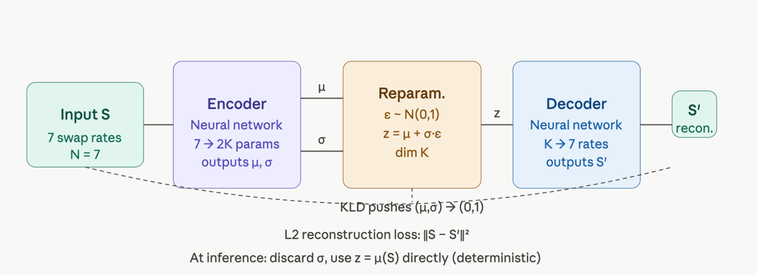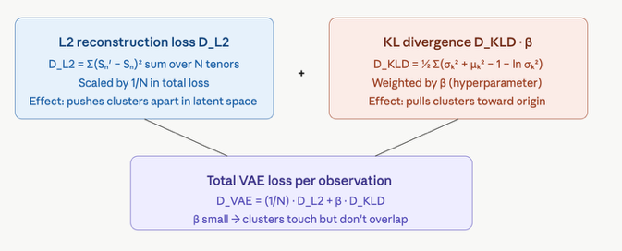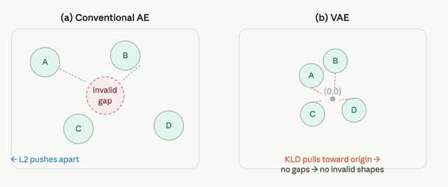
- Objective: This section answers the question: why a VAE rather than a standard autoencoder and how exactly does it work? We need the curve compression to satisfy two properties beyond mere accuracy:
  - Continuity: small changes in the curve produce small changes in the latent variables, and vice versa
  - Regularity: no abrupt gradient changes
A conventional autoencoder provides neither guarantee. The VAE solves this with a principled probabilistic mechanism, at the cost of one important hyperparameter.
- From conventional AE to VAE: A conventional autoencoder encodes each input curve $S$ to a single point $z$ in latent space, and trains by minimising reconstruction error $∥S-\text{decoder}(z)∥^{2}$. The encoder learns a deterministic mapping $S↦z$.
  - The problem: the training objective has no incentive to fill the latent space smoothly. The optimal solution for a conventional AE is to spread the latent representations of different curves as far apart as possible this maximises separation, making reconstruction easy. The result is a latent space full of "holes" between the clusters. Any point sampled from a hole decodes to a nonsensical curve, because the decoder was never trained on nearby points.
  - VAE BETTER: A VAE replaces the deterministic mapping $S↦z$ with a probabilistic one: $S↦N(μ(S),σ(S))$. The encoder no longer outputs a single point -> it outputs the parameters of a distribution over points. Training then samples a point $z$ from this distribution before decoding. This single change has profound consequences for the geometry of the latent space.
  - Sampling trick: The sampling step introduces a problem -> gradients cannot flow through a random sample. If $z∼N(μ,σ^{2})$, you cannot compute $∂z/∂μ$ or $∂z/∂σ$ because the sample is a random draw, not a differentiable function.
    - Kingma and Welling's solution is elegant. Instead of sampling $z$ directly, write: $z=μ+σ⋅ε,ε∼N\left(0,1\right)$. So Z is a deterministic function of ($μ,σ)$.
    - The gradients $∂z/∂μ=1$ and $∂z/∂σ=ε$ are well-defined and backpropagation flows normally through the encoder.
    - This means during each training step, the encoder takes a swap rate vector $S$, outputs ($μ,σ)$ for each latent dimension, and then the actual latent vector used for decoding is $z=μ+σ⋅ε$ with a freshly sampled $ε$. The decoder never sees exactly the same $z$ for the same curve twice during training.

- The loss function: The total VAE loss per observation is:
$$D_{\text{VAE}}(S,S^{'},μ,σ)=\frac{1}{N}D_{L2}(S,S^{'})+β⋅D_{KLD}(μ,σ)$$
  - L2 reconstruction loss : $D_{L2}(S,S^{'})=\sum_{n=1}^{N}{(}S_{n}^{'}-S_{n})^{2}$

    - This is a sum over the $N=7$ swap rates. Each term ${\left(S_{n}^{'}-S_{n}\right)}^{2}$ measures how far the reconstructed rate at tenor $n$ is from the observed rate. This drives the encoder and decoder to actually learn to compress and reconstruct.
    - The $\frac{1}{N}$ scaling factor in the total loss normalises the L2 contribution so that it does not depend on the number of tenors, making $β$ comparable across different configurations.
    - The geometric effect of $D_{L2}$ alone: it is a repulsive force. If two different curves $A$ and $B$ are encoded too close together in latent space, the decoder cannot reconstruct both accurately from nearby points, it would produce a blend, increasing L2 loss. So minimising L2 alone pushes all curve representations as far apart as possible, creating gaps.
  - KL divergence : $D_{KLD}(μ,σ)=\frac{1}{2}\sum_{k=1}^{K}{\left(σ_{k}^{2}+μ_{k}^{2}-1-ln⁡σ_{k}^{2}\right)}$

    - This closed-form expression measures how far the encoder's output distribution $N(μ_{k},σ_{k})$ is from the standard normal $N(0,1)$ in each latent dimension $k$.
    - $μ_{k}^{2}$ penalises the mean being far from zero (pulls the cluster toward the origin). $σ_{k}^{2}-1-ln⁡σ_{k}^{2}$ penalises the variance being too large or too small (pulls it toward 1).
    - The geometric effect of $D_{KLD}$ is an attractive force pulling all cluster centres $μ$ toward the origin and all spreads $σ$ toward 1. If it acted alone, all curves would collapse to the same point $\left(0 , 1\right)$, making reconstruction impossible.
  - The balance β:
    - The two forces compete. $β$ controls the strength of the KLD attractive force relative to L2 repulsion.
      - With $β$ small: clusters spread far apart, gaps appear, less regularisation.
      - With $β$ large: clusters collapse toward origin, overlapping, reconstruction degrades.
      - The right $β$ is the one where clusters are just close enough to "touch but not overlap" -> eliminating gaps without conflating distinct curve shapes.

Why sampling acts as a regulariser? Consider encoding a training curve $S_{A}$ to distribution $N(μ_{A},σ_{A})$. During training $z$ is sampled from this distribution, meaning $z$ is not always exactly at $μ_{A}$ but somewhere in its neighbourhood. The decoder must reconstruct $S_{A}$ accurately from any point in that neighbourhood not just from the centre $μ_{A}$.

This forces the decoder to learn a smooth reconstruction function in the vicinity of every training point. Contrast this with a conventional AE: the decoder only ever sees one specific $z$ per curve, so it can learn a wildly irregular function that memorises single points without generalising. The VAE's sampling step is equivalent to requiring the decoder to be smooth within the uncertainty radius $σ$ around every training point this is regularisation in the most literal geometric sense.

This is also why VAEs are less data-hungry: the effective number of training examples is much larger, because each curve generates a whole distribution of latent positions, each of which must decode correctly.

Post-processing by gradient descent: After training, the sampling step is dropped and the deterministic mapping $S↦μ(S)$ is used. But $μ(S)$ minimises the sum of L2 and KLD loss, not L2 alone. This means the encoder's best estimate of the latent position is slightly biased toward the prior it is "pulled" slightly toward the origin by the KLD term even at inference time.

For curve representation where accuracy matters (e.g., exact calibration to the market curve), this bias is unacceptable. The post-processing step performs gradient descent starting from $μ(S)$, optimising only the L2 reconstruction loss. This finds the true optimal latent point $z^{*}$ for a given curve $S$, unconstrained by the KLD penalty that was needed during training. The result is a more accurate encoding with no loss of the continuity and regularity properties, as long as the gradient descent trajectory stays within the well-regularised region of the latent space.

This is exactly analogous to curve building in classical finance: the Nelson-Siegel factors give you a good starting point, but you might then run a local optimizer to hit the observed quotes exactly. The VAE does the same thing with $μ(S)$as the warm start.

    - Conditional VAE (CVAE)
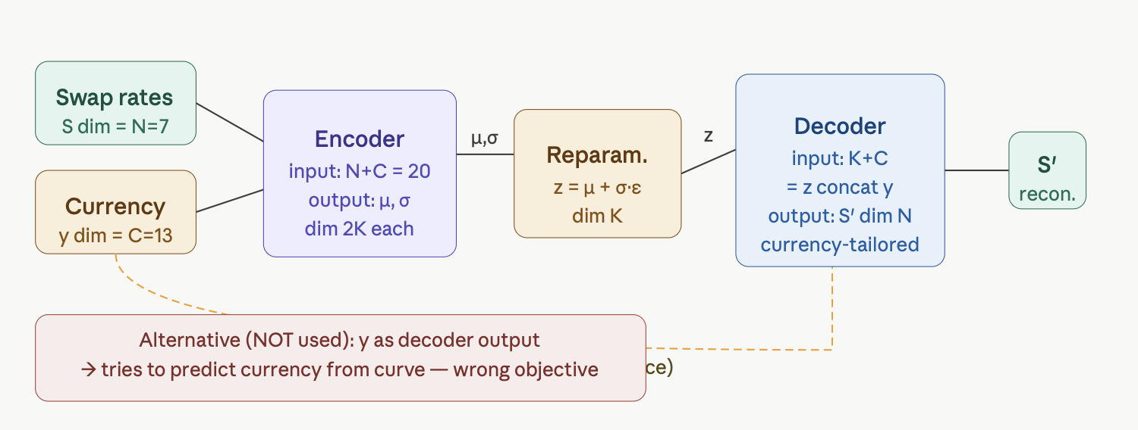

- Objective: The VAE described in the previous section works for a single currency. But the paper trains on data from 13 currencies simultaneously. Doing this naively raises an immediate question: how do you tell the model which currency a given curve belongs to? And more subtly: how do you encode that label without accidentally introducing false structure into the model? And also what to do when some currencies have very little historical data?

- The core idea: In the standard VAE, the encoder receives only the swap rate vector $S$ and produces $\left(μ , σ\right)$ in latent space. The decoder receives only $z$ and produces $S^{'}$. There is no mechanism by which the model can learn that, say, JPY curves tend to be flatter than USD curves, all currencies are treated identically. The CVAE adds the currency label $y$ as an additional input to both the encoder and the decoder. This is a simple but powerful change:
  - The encoder sees $\left(S , y\right)$ and produces $\left(μ(S,y),σ(S,y)\right)$ -> latent representations can now depend on the currency.
  - The decoder sees $\left(z , y\right)$ and produces $S^{'}(z,y)$ -> reconstructions are currency-tailored.
The latent space $z$ can now focus on encoding the currency-agnostic shape information, while the currency-specific adjustments are handled via $y$. This is a form of disentanglement: the model separates "what does this curve shape look like in general" (in $z$) from "what currency-specific adjustments are needed" (in $y$).
- The two types of CVAE: The paper is careful to flag an ambiguity in the literature. Two distinct architectures both go by the name "CVAE":
  - Type 1 (Sohn, Lee, Yan; used in this paper): The label $y$ is an input to both encoder and decoder. The model learns: given a curve and its currency, encode it; and given a latent code and a currency, decode a curve. The label is purely a conditioning signal, it is known at both training and inference time.
  - Type 2 (Kingma, Rezende, Mohamed, Welling; not used): The label $y$ is an input to the encoder but an output of the decoder. The decoder simultaneously reconstructs the curve and predicts the label. The model is asked: given a curve, infer both its latent code and its currency.
For yield curves, the same curve shape can appear in multiple currencies. Asking the decoder to predict the currency from the curve shape is therefore ill-posed. Additionally there is no practical interest in "guessing the currency" from a curve since the currency is always known. Type 1 is the correct choice here.
- Ordinal vs one-hot encoding:
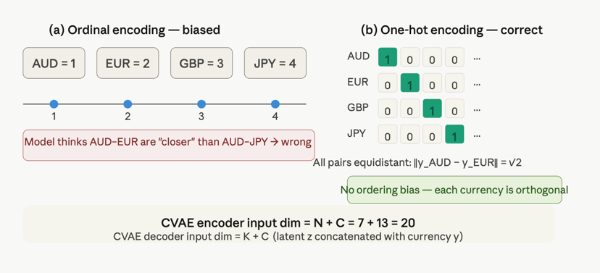
- The interpolation benefit: This is the most practically valuable feature of the CVAE for capital markets. Consider a currency that became a liquid swap market only recently (5 years of data instead of 20). A single-currency VAE trained on this data alone would overfit: it would have too few observations to reliably learn the curve's distributional properties.
The CVAE sidesteps this problem via interpolation in the currency subspace. During training, the model simultaneously processes all 13 currencies. The encoder learns a shared latent space for curve shapes, and the one-hot currency vectors form a 13-dimensional subspace within the input. For a data-scarce currency $c$, the model can implicitly borrow structure from nearby currencies, not because those currencies are numerically close (one-hot encoding prevents that), but because their curve shapes share latent features that the model has learned from the abundant data of other currencies.
Concretely: if the CVAE has learned that a certain latent pattern (say, a steeply inverted short end) appears frequently in USD and EUR curves, it can apply that same latent knowledge to reconstruct a similar shape for a data-scarce currency, even if that currency has only exhibited that shape a handful of times. The currency-specific adjustments (the decoder's use of $y$) handle the fine-grained differences, while the shared latent space handles the universal shape structure.
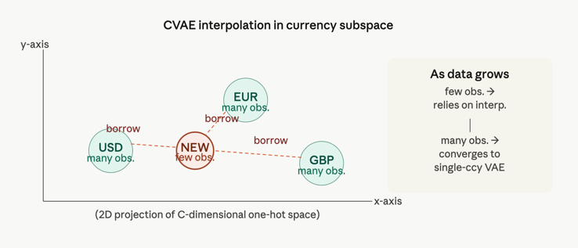
- Hypotheses and their realism:
  - yield curve shapes are partially universal across currencies: that there exists a shared latent structure that transcends individual currency dynamics. This is empirically well-supported: most developed-market curves exhibit similar macroeconomic dynamics (the level is driven by central bank policy expectations, the slope by the term premium, the curvature by convexity adjustments). The CVAE is designed to exploit exactly this cross-currency regularity.
  - The assumption that one-hot encoding fully captures the currency conditioning is more restrictive. It means the CVAE treats each currency as equally "different" from all others in the conditioning signal, so there is no way for the model to learn, for example, that EUR and CHF curves are structurally more similar than USD and JPY. This similarity can only emerge from the shared latent space, not from the encoding of y itself. In practice this is fine, since the shared latent z does capture these similarities, but it means the currency label provides no geometric structure, all structure must come from the data.

    - Multi-Currency VAE
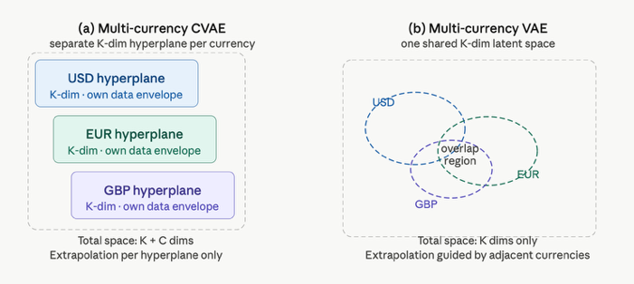
- Objective: This section raises a subtler but crucial question: is the CVAE actually the best way to share information across currencies? The answer turns out to be "not necessarily", and the alternative: a plain VAE trained on all currencies simultaneously with a shared latent space, has a structural advantage that matters directly for how these models are used in practice -> extrapolation outside historical data.
- The geometry of CVAE: To understand why the multi-currency VAE can outperform the CVAE, you need to understand what the CVAE's latent space actually looks like geometrically.
Recall that in the CVAE, the total input space has dimension $N+C=7+13=20$. The latent space has dimension $K$ (say 2). The encoder maps from 20 dimensions to 2. The one-hot currency vector $y$ effectively selects, for each currency $c$, a specific $K$-dimensional hyperplane within the $K+C$ dimensional joint space of latent variables and currency bits.
Concretely: for USD (currency 1), the input to the decoder is always $\left(z_{1},z_{2},1,0,0,…,0\right)$, the $K=2$ latent coordinates plus the USD one-hot bit set to 1. This defines a 2D slice through the $\left(K + C\right)$-dimensional space. For EUR, the slice is $\left(z_{1},z_{2},0,1,0,…,0\right)$. Each currency lives on its own 2D hyperplane, and these hyperplanes are parallel but disjoint, they share no points.
The historical data envelope for each currency is a compact region within its hyperplane, the set of latent points $\left(z_{1} , z_{2}\right)$ that correspond to swap rate vectors $S$ actually observed in history. Outside this envelope, the model is extrapolating. Within each hyperplane, the CVAE can extrapolate guided by the structure of that currency's own data, and cross-hyperplane guidance occurs through the shared encoder weights but the geometries of the separate hyperplanes do not directly touch.
The multi-currency VAE makes a radically different choice: it drops the currency conditioning entirely and trains a plain VAE on the combined dataset of all 13 currencies. Every observation, regardless of currency, is encoded into the same K-dimensional latent space.
This means USD curves, EUR curves, GBP curves, JPY curves, and all others share one common map. Their historical data envelopes overlap, as shown in the Figure. A JPY curve with a particular shape is encoded close to a EUR curve with a similar shape, even though these are different currencies. The latent space now represents universal yield curve shapes, not currency-specific representations.
- This is the central argument of Section 2.3.3, and it is a subtle but important one. In any stochastic model built on the VAE latent space, the state variable $z$ follows a stochastic process (an SDE or AR model, as developed in Chapters 3 and 4). In a Monte Carlo simulation, $z$ takes a random walk through the latent space. The question is: what happens when the walk takes $z$ outside the historical data envelope of the currency being modelled?
  - In the CVAE, each currency has its own hyperplane. When $z$ leaves the USD historical envelope within the USD hyperplane, the decoder must extrapolate using only the structure it learned from USD data. There is no adjacent data to guide it, the EUR hyperplane is geometrically separate.
  - In the multi-currency VAE, when $z$ leaves the USD historical envelope in the shared space, it does not immediately enter "uncharted territory". It enters regions where other currencies' data was encoded, EUR or GBP curves with shapes the USD curve has not yet exhibited. The decoder has seen this region before, trained on curves from other currencies. Extrapolation begins only once $z$ reaches a region where no currency's data is present, a far rarer event if the model is properly calibrated.
- The paper describes this as a three-zone structure:
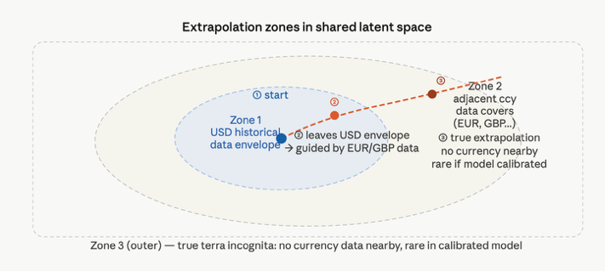
  - Zone 1 = USD historical envelope: $z$ is in a region where USD curves have been observed. The mapping is interpolation. This is the safest zone.
  - Zone 2 = Adjacent currency coverage: $z$ has left the USD envelope but is still within the envelope of some other currency (EUR, GBP, AUD, ...). The decoder has been trained here, guided by those currencies' data. This is "soft extrapolation" the model is generalising, but guided by real observations.
  - Zone 3 = True terra incognita: $z$ is so far from any historical data, for any currency, that the decoder is extrapolating blindly. The paper notes this should be "a rare occurrence in a properly calibrated model", if the stochastic process's calibration is sensible, it will not routinely drive $z$ into the outermost regions of the latent space.
This three-zone structure gives the multi-currency VAE a structural advantage over the CVAE for model construction: its Zone 2 is a meaningful buffer that does not exist in the CVAE's per-hyperplane geometry.

- The three network architectures :
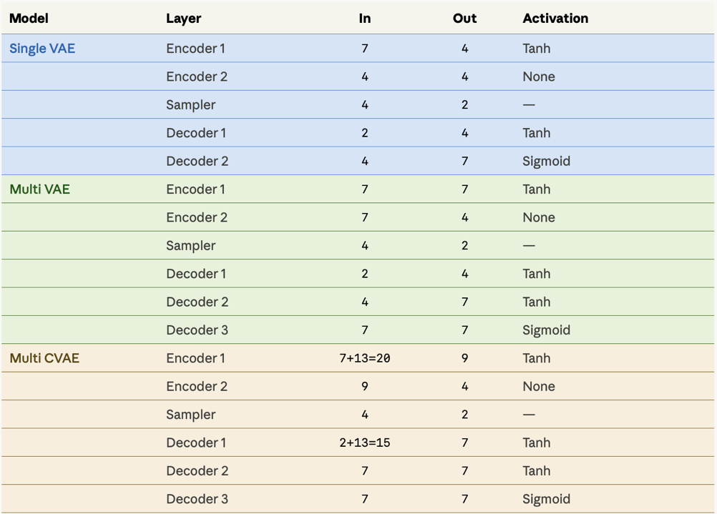

Single-currency VAE : The architecture is deliberately shallow -> two encoder layers and two decoder layers, plus the sampler.
Encoder 1: $7→4$, Tanh activation. Takes the 7 swap rates and compresses to 4 hidden units. Tanh is used because it is bounded, preventing extreme activations that could destabilise the KLD term.
Encoder 2: $4→4$, no activation (linear). Outputs the $2K=4$ parameters — two $μ$ values and two $σ$values (before softplus) for the 2-dimensional latent space. Linear output is standard for the final layer producing distribution parameters.
Sampler: $4→2$. Takes $\left(μ_{1} , μ_{2} , σ_{1} , σ_{2}\right)$ and produces $z=μ+σ⋅ε$ with $ε∼N(0,1)$. This is not a trainable layer — it is the reparameterization operation. Output dimension is $K=2$.
Decoder 1: $2→4$, Tanh. Expands the 2-dimensional latent code back to 4 hidden units.
Decoder 2: $4→7$, Sigmoid. Produces the 7 reconstructed swap rates. Sigmoid is used here because swap rates are bounded non-negative values in the training data after normalisation — Sigmoid constrains the output to $\left(0 , 1\right)$, which maps to the normalised rate range.

Multi-currency VAE: The architecture is slightly deeper -> three decoder layers -> reflecting the increased complexity of reconstructing curves from 13 different currencies from a shared latent space.
Encoder 1: $7→7$, Tanh. Notably, the input dimension is still 7 -> the currency label is not provided. The output is also 7, maintaining the representation width before compression.
Encoder 2: $7→4$, None (linear). Produces the $2K=4$ parameters for $\left(μ , σ\right)$.
Sampler: $4→2$, reparameterization.
Decoder 1: $2→4$, Tanh.
Decoder 2: $4→7$, Tanh. Note: Tanh here instead of Sigmoid — an additional layer follows.
Decoder 3: $7→7$, Sigmoid. The final output layer. The extra decoder depth (3 vs 2 layers) gives the decoder more capacity to learn the currency-specific adjustments that were previously handled by the explicit currency conditioning in the CVAE. Without the currency label, the decoder must infer currency-specific adjustments entirely from the latent code and its own learned structure.

Multi-currency CVAE: Here the architecture must handle the concatenated inputs.
Encoder 1: $7+13=20→9$, Tanh. The "+13" denotes the one-hot currency vector appended to the 7 swap rates. Output is 9 units — the paper notes "where two numbers are specified, the second number refers to C = 13 additional dimensions". This is the most data-rich encoder input.
Encoder 2: $9→4$, None. Produces $\left(μ , σ\right)$ parameters.
Sampler: $4→2$.
Decoder 1: $2+13=15→7$, Tanh. The latent code $z∈R^{2}$ is concatenated with the one-hot currency vector before decoding. This gives the decoder explicit knowledge of the currency for the reconstruction.
Decoder 2: $7→7$, Tanh.
Decoder 3: $7→7$, Sigmoid. Final output.
  - Results:
- The dataset: The training data covers daily observations of 7 swap rates (2Y, 3Y, 5Y, 10Y, 15Y, 20Y, 30Y) for 13 currencies: AUD, CAD, CHF, CZK, DKK, EUR, GBP, JPY, MXN, NOK, SEK, USD, ZAR. Both LIBOR and OIS curves are included. Only dates where all 7 maturities were present are used.

- Why daily ≈ monthly matters: The paper argues that training frequency (daily vs monthly) is largely irrelevant for curve shape compression. The reason: the VAE is learning a distribution over curve shapes, not a model of how shocks evolve day-to-day. Consecutive daily observations of yield curves are highly autocorrelated, the shape on Tuesday is almost identical to Monday's shape. Adding more days gives you more samples, but they are nearly redundant for the purpose of characterizing the space of possible curve shapes.

- Normalization: Before entering the encoder each swap rate $S_{n}$ is mapped linearly from the interval $\left[-5\%,25\%\right]$ to $(0,1)$:
$${\tilde{S}}_{n}=\frac{S_{n}-(-5\%)}{25\%-(-5\%)}=\frac{S_{n}+5\%}{30\%}$$
- Equal weights in L2 loss: The paper explicitly chooses equal weights for all swap rates in the L2 reconstruction loss -> unequal spacing of liquid swap tenors naturally overweights shorter maturities (there are more liquid points per unit of maturity at the short end). The implication is that a 1bp error at the 2Y tenor costs the same as a 1bp error at the 30Y tenor in the training objective.

- The $β={10}^{-7}$ choice: This extremely small $β$ is the most practically important hyperparameter. Recall that $β$ controls the strength of the KLD regularization relative to reconstruction accuracy. With $β={10}^{-7}$, the KLD term is nearly negligible in the loss function, the model is trained primarily to minimise reconstruction error, with just enough KLD regularisation to ensure the latent space is continuous and gap-free. This is much smaller than the $β=1$ used in the original VAE paper, and explains why the reconstruction accuracy is competitive with Nelson-Siegel: the model is barely compromising accuracy for regularity. The KLD term is used as a "light touch" regulariser, not as a strong prior.

- logvar encoding: The paper uses the standard $\left(μ,log⁡σ^{2}\right)$ parameterisation (logvar) rather than $\left(μ , σ\right)$ directly. The KLD formula in this convention becomes:
$$D_{KLD}=\frac{1}{2}\sum_{k}{\left(e^{\log{σ_{k}^{2}}}+μ_{k}^{2}-1-log⁡σ_{k}^{2}\right)}$$
Using logvar instead of $σ$ directly avoids the need for a softplus and improves numerical stability during training.

- Dimension of latent space:
  - The one-factor failure: A 1-dimensional latent space is insufficient for multi-currency use. In the shared latent space of the multi-currency VAE, only one number $z$ would describe both the level and the shape of the curve for all currencies simultaneously. This forces every currency to produce identical curve sequences -> only the level changes not the shape -> which is equivalent to the classical one-factor model where all rates move in perfect parallel with 100% correlation. This is empirically wrong and practically useless.
  - Why $K=2$ suffices? The paper's main quantitative finding in this subsection is that two latent dimensions are sufficient to encode swap rates across all 13 currencies with accuracy comparable to Nelson-Siegel's three dimensions. With $K=2$, different currencies can occupy different regions of the shared 2D latent space. A EUR curve can be encoded at $\left(z_{1}=-0.8,z_{2}=0.3\right)$ while a USD curve sits at $\left(z_{1}=0.2,z_{2}=-0.1\right)$, they coexist in the same space without conflict. The two dimensions can independently encode different curve features (one dominated by level, one by shape), allowing the model to distinguish between a steep USD curve and a flat EUR curve even though they share the same latent space. The parsimony argument is also made here: a 2D VAE has fewer parameters to estimate in the downstream stochastic model than a 3D Nelson-Siegel basis. Fewer parameters means more stable calibration, lower estimation uncertainty, and better out-of-sample behaviour of the interest rate model built on top.

- The RMSE distribution: compares the three architectures on in-sample reconstruction. The key findings:
  - Multi-currency methods dominate single-currency VAE by a large margin. This confirms that training across 13 currencies simultaneously forces the VAE to learn a richer, more universal representation of curve shapes. The single-currency VAE, trained on one currency at a time, lacks the diversity of training examples needed to efficiently compress the full variety of curve shapes.
  - CVAE is slightly better than multi-currency VAE. The explicit currency conditioning in the CVAE allows currency-specific adjustments that the shared latent space of the multi-currency VAE cannot make. However, the gap is described as "not dramatic", suggesting that the 2D shared space has enough capacity to implicitly separate currencies without being told their identities.

the key comparison: VAE/CVAE (2 dim) vs Nelson-Siegel (3 dim):

Multi-currency CVAE (2 dim) ≈ Nelson-Siegel (3 dim) in reconstruction accuracy. This is the paper's headline result. A data-driven compression with one fewer dimension achieves similar accuracy to the classical hand-crafted parametric basis.

Multi-currency VAE (2 dim) is somewhat lower but still comparable. Even without the currency conditioning advantage, the shared latent space VAE is competitive with Nelson-Siegel.
The interpretation is direct: the VAE's learned basis functions are better adapted to the actual geometry of yield curve data than Nelson-Siegel's analytically prescribed basis functions. Even with one fewer dimension, the VAE wastes less of its representational capacity on curve shapes that never occur and can therefore represent the curves that do occur more accurately. The paper adds a telling observation: the VAE achieves this without any knowledge of what swap maturities are or even their ordering. Nelson-Siegel, by contrast, is defined explicitly as a function of maturity $τ$ -> the ordering information is baked in. The fact that the VAE matches it despite being completely blind to maturity structure is a powerful validation of the approach.

- Models in Q-Measure

This preamble answers a foundational question: why would you ever replace a classical, analytically tractable interest rate model with something more complex?

When the first term structure models appeared (Vasicek 1977, Hull-White 1990, HJM 1992, BGM/LMM 1997), the dominant use case was front-office derivative pricing: traders needed to price and hedge interest rate options, caps, floors, swaptions -> fast, reliably, with Greeks available in real time. Analytical solutions (closed-form formulas) were essential for this. A model that required Monte Carlo simulation was simply not competitive for real-time trading.
To obtain analytical solutions, models had to make strong simplifying assumptions: Gaussian/normal volatility (Hull-White) / Log-normal volatility (LMM) / Constant mean reversion speed / Separable volatility structures. The paper is explicit: "Practitioners are well aware that financial markets follow these behaviors at best approximately, but willing to tolerate model error for the performance gain of an analytical solution." This is a frank acknowledgment that classical models are known to be wrong, and the question is only whether the error matters for the calculation at hand.

"imply from market prices what you can (really) hedge, and estimate econometrically what you cannot."

  - Forward Rate Models
    - HJM and LMM Models

The forward rate SDE: $dF_{n}=μ_{n}(t,F) dt+σ_{n}(t,F) dw_{n}$

This single equation defines the entire HJM/LMM model family.

What is $F_{n}$? $F_{n}$ is the simple forward rate -> this is the rate at which you could lock in today a loan starting at $T_{n}$ and maturing at $T_{n+1}$. The word "simple" distinguishes it from continuously compounded rates.

What is $μ_{n}(t,F)$? This is the drift, the expected rate of change of $F_{n}$ per unit time under the Q-measure -> it is not a free parameter -> It is completely determined by the volatility structure. This is the HJM constraint.

What is $σ_{n}(t,F)$?This is the volatility of the $n$-th forward rate. It can depend on:

Time $t$ (time-varying volatility)

The full forward curve $F$ (level-dependent or path-dependent volatility)

The choice of $σ_{n}$ is the primary design decision in any HJM/LMM model.
      - Gaussian HJM : $σ_{n}(t,F)=σ_{n}(t)$
      - LMM (equation 9): $σ_{n}(t,F)=F_{n}σ_{n}(t)$
      - CEV (Andersen-Andreasen): $σ_{n}\left(t,F\right)=F_{n}^{β}σ_{n}\left(t\right)$
      - SABR-LMM: volatility $σ_{n}$ itself follows a stochastic process.

What is $dw_{n}$? These are correlated Brownian motion increments. The correlation structure is: $⟨dw_{n} dw_{n^{'}}⟩=ρ_{nn^{'}} dt$ where $ρ_{nn^{'}}$ is the instantaneous correlation between the $n$-th and $n^{'}$-th forward rate shocks

The rolling numeraire : $B_{n}(T_{n+1})=\prod_{n^{'}=0}^{n}{(1+}δ_{n^{'}}F_{n^{'}})$. The numeraire is the reference asset against which all prices are measured. In LMM, the rolling numeraire is the value of $1$ invested in a sequence of deposits, each reinvested at the prevailing forward rate. At each period end $T_{n+1}$, the account has grown by the factor $\left(1 + δ_{n}F_{n}\right)$. Why does this matter? The no-arbitrage condition requires that discounted prices (prices divided by the numeraire) are martingales under Q. The stochastic discount factor follows immediately: $\text{SDF}(t,T)=\frac{B(t)}{B(T)}=\prod_{\left.n:T_{n}∈[t,T\right)}{\frac{1}{1+δ_{n}F_{n}}}$

The no-arbitrage condition: $V(t)=E^{Q}\left[V(T)⋅\text{SDF}(t,T) | X(t)\right]$

The HJM drift constraint: $μ_{n}(t,F)=σ_{n}(t,F)\sum_{n^{'}}{\frac{ρ_{nn^{'}} δ_{n^{'}} σ_{n^{'}}(t,F)}{1+δ_{n^{'}}F_{n^{'}}}}$

This is the HJM drift restriction: in a Q-measure model, you cannot choose the drift independently of the volatility. The volatility determines the drift. This is not a modelling assumption, it is a mathematical necessity for no-arbitrage.

Once you specify $σ_{n}(t,F)$ and $ρ_{nn^{'}}$, every $μ_{n}$ is fixed. There are no remaining free parameters in the drift. This has a profound consequence: the only way to control how rates move relative to each other is through the correlation matrix $ρ_{nn^{'}}$. This is the sole mechanism left available.

Correlation as curve shape control: Classical LMM/HJM models control curve shapes indirectly through correlations: nearby rates move together, which reduces the chance of unrealistic kinks or humps. But this is only a statistical constraint, not a hard rule. Over long horizons (e.g. 20-year simulations), small inconsistencies accumulate, and the model increasingly generates economically implausible curves that were never observed historically. In short, correlation-based control weakens over time -> this is why the paper replaces it with VAE-based control, which enforces realism directly.

The volatility basis : $σ_{n}(t,F)=\sum_{k=1}^{K}{σ_{k}}(t,T_{n},F) dw_{k}$
This is the low-rank decomposition of the volatility structure. Instead of $N$ independent Brownian drivers (one per forward rate), the model uses $K≪N$ drivers. This is equivalent to reducing the rank of the correlation matrix $ρ_{nn^{'}}$ to $K$. Why does this help? Because with $K$ drivers, the forward curve can only move in $K$ directions. This constrains the possible curve shapes — the curve cannot develop arbitrary deformations. With $K=2$, the curve can shift and twist. With $K=3$, it can also butterfly. With $K=4$, it can produce more complex shapes.
In classical models, $σ_{k}(t,T_{n},F)$ is determined by:
  - PCA on historical rate shocks: compute the covariance matrix of daily changes in forward rates across history, perform eigen decomposition and take the top $K$ eigenvectors.
  - Parametric forms: specify $σ_{k}(t,T_{n},F)$ analytically, for example as $e^{-a_{k}(T_{n}-t)}$ (exponential decay), which corresponds to the Hull-White volatility profile.
Both Fails for long horizons -> because both approaches share the same fundamental limitation: they are exogenous, chosen without reference to the actual distribution of historical yield curve shapes. The VAE basis, by contrast, is endogenous, derived directly from the historical data manifold. This is the gap equation (14) of the forward rate AEMM fills.

    - AFNS and FHJM Models

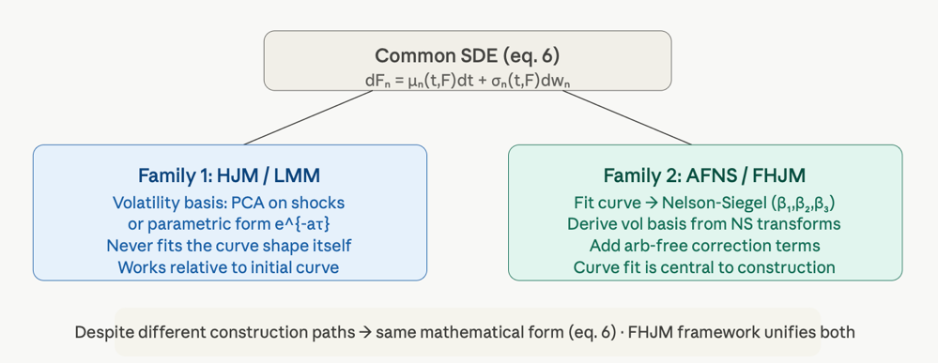
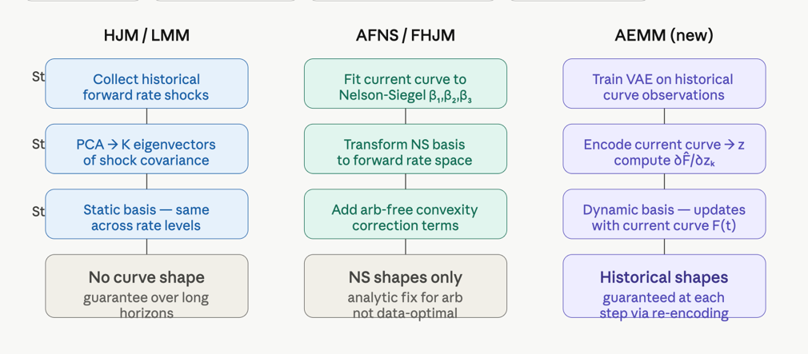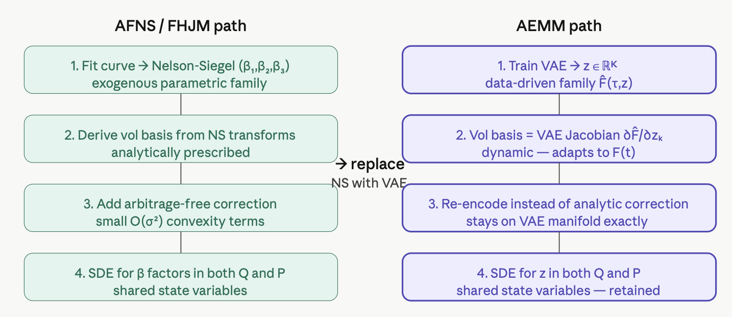

- The two families - same equation, different philosophy: Both model families are specified by the same SDE and both satisfy the HJM drift constraint
  - HJM/LMM - shock-first construction: In this family, the model is built entirely around the dynamics of curve shocks. The modeller specifies the volatility $σ_{n}(t,F)$ (either parametrically or via PCA on historical shocks) and the correlation $ρ_{nn^{'}}$, derives the drift from equation, and the model is complete. At no point in this construction does the modeller ask: "what does the yield curve actually look like?" The initial curve is fitted separately (by a curve-building algorithm) and the model is expressed as *deviations from* that initial curve. The shape of the curve at any future time is an emergent consequence of the dynamics, not an input to the model design. They describe velocities and accelerations without ever specifying the position.
  - AFNS/FHJM - curve-first construction: This family starts from the opposite end. The first step is to fit the current yield curve to the Nelson-Siegel parametric form: $R(τ)=β_{1}+β_{2}\frac{1-e^{-λτ}}{λτ}+β_{3}\left(\frac{1-e^{-λτ}}{λτ} − e^{-λτ}\right)$ obtaining factors $\left(β_{1} , β_{2} , β_{3}\right)$. The volatility basis is then derived from transformations of this fit — specifically, from the derivatives of the Nelson-Siegel curve with respect to its factors. Arbitrage-free correction terms are added to ensure the model satisfies the no-arbitrage constraints. The result is a forward rate model whose dynamics are anchored to the Nelson-Siegel curve shapes. They specify positions first, then velocities.

The dual-measure state variable problem: In practice, interest rate models are used in two fundamentally different contexts:

Q-measure (pricing): pricing derivatives, calculating hedge ratios, computing XVA. Models used here are specified under the risk-neutral measure, calibrated to market prices of liquid instruments (swaptions, caps).

P-measure (risk management, forecasting): scenario generation for stress testing, macro forecasting, Value-at-Risk, counterparty credit risk. Models used here describe the actual (historical) distribution of rates. The most popular framework is the Dynamic Nelson-Siegel model of Diebold and Li, which models the time evolution of $\left(β_{1} , β_{2} , β_{3}\right)$ as a vector autoregression (VAR): $\left(\begin{aligned}β_{1}(t) \\ β_{2}(t) \\ β_{3}(t)\end{aligned}\right)=A\left(\begin{aligned}β_{1}(t-1) \\ β_{2}(t-1) \\ β_{3}(t-1)\end{aligned}\right)+ϵ(t)$

The inconsistency problem: A trading desk might use LMM (with forward rates as state variables) for Q-measure pricing and Dynamic Nelson-Siegel (with NS factors as state variables) for P-measure risk management. These two models have completely different state variables. To compute quantities that require both measures you need a bridge between the two. This bridge is painful to build and introduces additional approximation errors.

AEMM retains the ability to share state variables between Q- and P-measure, while replacing Nelson-Siegel factors with VAE latent variables $z∈R^{K}$. The improvement is that VAE latent variables are strictly better than NS factors as a basis for both measures:

Better compression: VAE achieves comparable accuracy with one fewer dimension, so the state space is more parsimonious.

Better realism: VAE's learned basis adapts to the actual distribution of historical curves, not to an analytically prescribed parametric family.

Better extrapolation: the VAE manifold provides a data-driven constraint on which curve shapes are reachable, whereas NS allows unrealistic combinations of $β_{1},β_{2},β_{3}$.

Dynamic basis: the AEMM volatility basis (equation 14) depends on the current curve level, unlike the static NS basis functions.

    - Forward Rate AEMM

- Models in P-measure

- Conclusion

